After running the code, the device run panic mode.

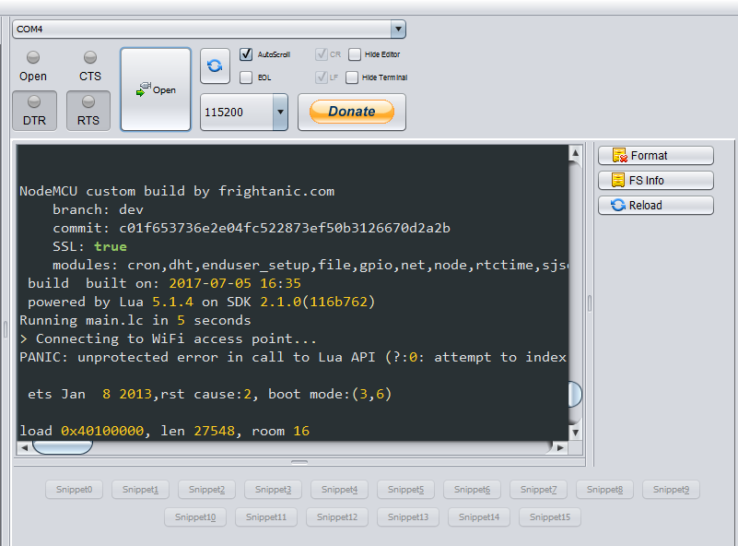

The error message is

PANIC: unprotected error in call to Lua API (?:0: attempt to index global 'io' (a nil value))